SIMATS ENGINEERING (SAVEETHA SCHOOL OF ENGINEERING)
Department of Computer Science and Engineering
CO5 ASSESSMENT TOOL 1 – Research Paper Review / Literature Survey

Course Code: | CSA10 | Course Title: | Software Engineering
CO Assessed: | CO5 | Assessment: | Assessment Tool 1 – Research Paper Review / Literature Survey
Weightage: | 20% | Total Marks: | 25
CO5 Statement: | Evaluate emerging technologies and societal impacts, maintaining and evolving software systems responsibly
Student Name: | K Sujith Sai Vighnesh | Reg. No.: | 192311199
Date: | 25-08-2026 | Duration: | 60 minutes

Code of Conduct

I K Sujith Sai Vighnesh -- 192311199 certify that this submission is my original work and that I have adhered to the guidelines specified for this assessment. I understand that any violation of academic integrity rules will result in disciplinary action.
Signature of the Student:K Sujith Sai Vighnesh

LITERATURE SURVEY REPORT
AI-Powered Smart Disaster Relief Resource Allocation and Coordination Platform

Abstract
Natural disasters demand rapid, accurate, and well-coordinated allocation of scarce relief resources such as food, medicine, shelter, and rescue equipment. This report presents a literature survey conducted for the problem statement “AI-Powered Smart Disaster Relief Resource Allocation and Coordination Platform,” which aims to combine Artificial Intelligence (AI), Geographic Information Systems (GIS), the Internet of Things (IoT), and cloud computing to improve demand estimation, logistics optimization, inventory visibility, and multi-agency coordination during disasters. Eighteen peer-reviewed and preprint research works spanning 2013-2026 were reviewed and compared on methodology, technology, dataset, performance, and limitations. The survey finds substantial progress in isolated components — disaster prediction, damage assessment, resource-scheduling optimization, IoT sensing, and GIS-based situational awareness — but identifies a persistent gap in end-to-end platforms that unify real-time demand prediction, optimized logistics, shelter/inventory monitoring, and transparent multi-agency coordination within a single, explainable, and equitable system. Based on this gap, future research directions and design recommendations for the proposed platform are outlined.

- Introduction

During natural disasters — floods, earthquakes, cyclones, and wildfires — relief organizations, government agencies, and NGOs must rapidly estimate the needs of affected populations and distribute food, medicine, shelter, and rescue equipment before conditions worsen. In practice, relief operations are frequently delayed by fragmented communication channels between agencies, inaccurate or slow demand estimation, and inefficient allocation of transport and inventory resources. Responders often lack a single, real-time view of what resources are available, where they are located, and where they are most urgently needed, which results in duplicated effort in some areas and unmet needs in others.
Advances in Artificial Intelligence (machine learning, deep learning, and reinforcement learning), Geographic Information Systems (GIS), the Internet of Things (IoT), and cloud/blockchain-based data-sharing infrastructures create an opportunity to build an integrated disaster relief coordination platform. Such a platform would ideally: (i) assess disaster severity and predict resource demand using AI models trained on historical and real-time data; (ii) optimize the routing and scheduling of relief logistics under uncertain and damaged transportation networks; (iii) monitor shelter occupancy and inventory levels in real time via IoT sensing; and (iv) provide a shared, transparent coordination layer across government agencies, NGOs, and emergency responders.
This report surveys the existing body of research relevant to each of these sub-problems, compares the proposed approaches, identifies their limitations, and derives the research gaps and future directions that motivate the design of the proposed AI-powered platform.

1.1 Scope and Objectives of the Survey
- Identify credible, recent research addressing AI-based disaster demand prediction, resource allocation, logistics optimization, IoT/GIS-based monitoring, and multi-agency coordination.
- Summarize the objective, methodology, technology/dataset, and key findings of each selected paper.
- Compare the papers on accuracy, performance, scalability, and methodological approach.
- Identify limitations and challenges reported across the literature.
- Derive the research gap relevant to building an integrated, real-time disaster relief coordination platform.
- Propose future research directions and design implications for the proposed system.

2. Literature Survey Methodology
Research papers were identified from reputed scholarly sources including IEEE Xplore, ScienceDirect, SpringerLink, ACM Digital Library, PubMed Central (PMC), Taylor & Francis Online, Wiley Online Library, and the arXiv preprint repository, using combinations of the keywords: “AI disaster resource allocation “emergency resource scheduling,” “disaster demand forecasting machine learning,” and “multi-agency disaster response coordination.” Papers published between 2013 and 2026 were prioritized to capture both foundational coordination challenges and the latest AI/ML/GIS-IoT techniques. Eighteen papers were shortlisted based on relevance to the four functional pillars of the proposed platform: (a) AI-based prediction and decision support, (b) optimization-based logistics and routing, (c) IoT/GIS-based real-time monitoring, and (d) multi-agency coordination and data governance.
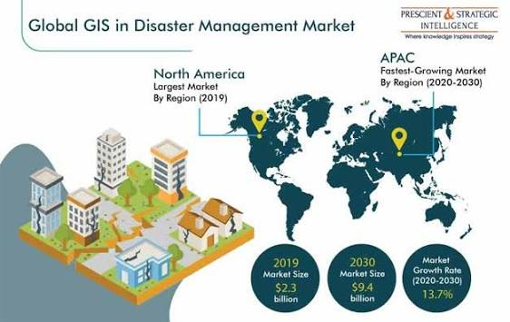
3. Review of Selected Research Papers

3.1 AI-Based Prediction, Decision Support, and Resource Optimization
3.1.1 Applications of Artificial Intelligence in Disaster Management [1]
Objective: Survey how AI techniques can be applied across all four phases of the disaster-management cycle (mitigation, preparedness, response, recovery).
Methodology: Structured literature review covering ML/DL, NLP, and computer-vision applications.
Technology/Dataset: Social-media feeds, satellite imagery, sensor data, and prior published studies.
Key Findings: AI can optimize allocation and delivery of food, water, medical supplies, and shelter by jointly analyzing needs, available resources, and logistics constraints; AI also helps filter high-volume social-media data during crises.
Limitations: Purely descriptive; does not propose or evaluate a working system.
3.1.2 Enhancing Disaster Response Systems: Predicting and Mitigating the Impact of Natural Disasters Using AI [2]
Objective: Develop an AI-driven framework to predict disaster occurrence and optimize resource allocation for emergency management.
Methodology: Deep-learning forecasting models combined with reinforcement-learning based dynamic resource-allocation algorithms.
Technology/Dataset: Historical disaster records, meteorological trends, and sensor-network data.
Key Findings: Reinforcement-learning-based allocation dynamically distributes emergency supplies, medical personnel, and evacuation routes based on real-time risk assessment, reducing response time and casualties; AI chatbots and decision-support tools were shown to aid responders.
Limitations: High computational cost, data-integration complexity, and the need for robust AI-governance frameworks are noted as open challenges; no real-world field deployment is reported.
3.1.3 Potential Use of Artificial Intelligence in Disaster Risk and Emergency Health Management [3]
Objective: Critically appraise how AI can support disaster forecasting, response, and recovery, including emergency health management.
Methodology: Narrative/critical appraisal of published literature.
Technology/Dataset: Publicly available secondary literature; no primary dataset.
Key Findings: AI combined with GIS, satellite imaging, and remote sensing improves routing for first responders, evacuation planning, and post-disaster damage/hazard assessment.
Limitations: Conceptual synthesis without quantitative validation or a prototype system.
3.1.4 Leveraging AI for Natural Disaster Management: Takeaways from the Moroccan Earthquake [4]
Objective: Demonstrate how deep-learning-based image analysis and optimization models can support post-earthquake relief planning.
Methodology: CNN and transformer-based models for road/infrastructure damage detection, combined with facility-location and relief-routing optimization models.
Technology/Dataset: Drone and satellite imagery; building- and road-damage datasets.
Key Findings: Deep-learning damage assessment provides accurate input for route planning and the strategic positioning of humanitarian logistics centers; several optimization models for medical-aid facility location and relief-supply delivery are surveyed.
Limitations: Damage-detection and logistics-optimization stages are handled by separate models with limited automated integration.
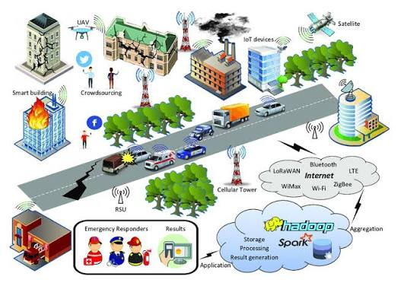
3.1.5 Leveraging AI for Disaster Management: A Comprehensive Review of Applications and Challenges [5]
Objective: Evaluate the effectiveness of AI in predictive disaster management and resource optimization.
Methodology: Mixed-methods approach: systematic literature review plus quantitative analysis of six real-world case studies.
Technology/Dataset: Six disaster case studies incorporating AI tools.
Key Findings: Machine-learning models improved disaster prediction accuracy by up to 25% over traditional models; AI-driven systems (including drones and predictive analytics) optimized resource allocation by up to 30%.
Limitations: Small case-study sample; raises unresolved ethical concerns around privacy and equitable division of resources.
3.1.6 Multi-Objective Emergency Resource Scheduling in Chemical Industrial Parks [6]
Objective: Address the trade-off between timeliness, adequacy, and fairness in emergency resource dispatching for chemical-park (multi-hazard) accidents.
Methodology: Three-objective mixed-integer programming model (time efficiency, demand coverage, allocation fairness) solved with an improved NSGA-II genetic algorithm, using elite-reservation and congestion-adaptive strategies.
Technology/Dataset: Simulated multi-warehouse, multi-hazard chemical-park scenarios.
Key Findings: The improved NSGA-II outperformed a weighted-sum method and MOGWO on convergence, diversity, and stability; a novel standard-deviation-based fairness index was proposed for dynamic resource balancing.
Limitations: Domain-specific to chemical-industrial-park hazards; not evaluated for large-scale, multi-agency natural-disaster settings.
3.1.7 Human-AI Use Patterns for Decision-Making in Disaster Scenarios: A Systematic Review [7]
Objective: Systematically review how human judgment and AI automation are combined for disaster-related decision-making, including resource and task coordination.
Methodology: Systematic review synthesizing KNN classification, multi-agent Markov Decision Processes (MDPs), attention-based hybrid planning, and Intelligent Decision Support Systems (IDSS).
Technology/Dataset: Socio-demographic/environmental data for shelter allocation; simulated multi-agent/multi-robot coordination environments.
Key Findings: A KNN-based classifier for temporary-housing allocation achieved 85% accuracy in matching population needs to available shelter resources; MDP-based frameworks successfully modeled human-agent collaborative resource deployment under uncertainty; IDSS supported multi-robot coordination even with delayed or incomplete information.
Limitations: Most approaches are validated only in simulation; robust handling of delayed/incomplete real-world data remains immature.
3.1.8 AI and Big Data in Disaster Response: Ethical and Practical Challenges [8]
Objective: Examine the ethical and practical implications of AI/big-data-driven disaster response and resource allocation.
Methodology: Critical/conceptual analysis of deployed and proposed AI-big-data disaster-response systems.
Technology/Dataset: Literature and documented case examples.
Key Findings: AI and big data significantly enhance predictive analytics, crisis communication, and resource allocation, but deployment can reinforce systemic inequalities and disproportionately affect marginalized communities if fairness is not designed in.
Limitations: Does not propose a technical fairness-aware allocation mechanism; remains at the level of critique and recommendation.

3.2 IoT, GIS, and Real-Time Coordination Technologies
3.2.1 Research on Emergency Logistics Information Traceability and Resource Optimization Using Consortium Blockchain [9]
Objective: Improve traceability, accuracy, and fairness of emergency-logistics resource allocation.
Methodology: Consortium blockchain for decentralized, immutable, transparent information sharing, combined with a Hybrid Genetic Simulated Annealing (HGASA) algorithm for allocation optimization.
Technology/Dataset: Simulated emergency-logistics network scenarios.
Key Findings: The blockchain-HGASA model reduced total transportation time and cost while improving fairness of resource allocation compared with traditional emergency-logistics models.
Limitations: Blockchain consensus introduces computational overhead; not tested at national, multi-agency scale, and lacks live IoT sensor integration.
3.2.2 Developing Real-Time IoT-Based Public Safety Alert and Emergency Response Systems [10]
Objective: Build a real-time, multi-sensor IoT system for public-safety alerting and escalation to emergency response agencies.
Methodology: IoT sensor fusion (fire, gas, biometric, motion) with a weighted severity-scoring engine and GIS-based control-room dashboards; tiered alert escalation to responders and the public.
Technology/Dataset: Multi-sensor smart-city simulation testbed.
Key Findings: The system achieved sub-450 ms alert latency, over 95% detection accuracy, and scalability to more than 12,000 concurrent devices, with autonomous escalation to national disaster-response agencies for critical, multi-sensor-verified events.
Limitations: Validated only in a controlled smart-city simulation lab, not in an actual large-scale natural disaster; no downstream logistics/allocation module.
3.2.3 AI and Machine-Learning-Powered GIS for Proactive Disaster Resilience [11]
Objective: Review how AI-enhanced GIS can support proactive, climate-resilient disaster management.
Methodology: Systematic literature review of AI+GIS integration for monitoring, early warning, and coordination.
Technology/Dataset: Secondary literature synthesis across multiple studies.
Key Findings: AI-GIS platforms can process multi-source real-time data to improve accuracy and timeliness of disaster response and to enhance multi-agency collaboration through shared real-time intelligence.
Limitations: Review-level evidence; implementation costs, data-interoperability, and governance barriers are not quantified.
3.2.4 The Role of GIS in Disaster Response and the EMHelp Decision-Support System [12]
Objective: Improve multi-hazard situational awareness and inter-agency response coordination, illustrated through the EMHelp system developed for Algeria's ORSEC emergency-planning framework.
Methodology: Integration of Building Information Modeling (BIM), GIS, and IoT sensors for an open disaster-information platform; EMHelp uses ML/DL with scenario-based simulation and human-validated decision output.
Technology/Dataset: Multi-risk databases, IoT sensor feeds, structural/BIM models.
Key Findings: The BIM-GIS-IoT platform optimized evacuation routes and improved response times in simulation and real-world deployment tests; EMHelp improved decision-making and inter-agency collaboration within a national regulatory framework.
Limitations: Operational challenges persist, including delayed decision-making, poor inter-agency coordination, and limited real-time data integration in practice; the framework is tailored to a specific national regulatory context.
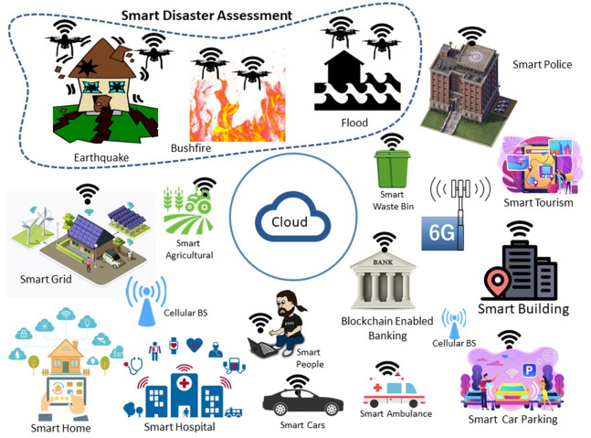
3.2.5 Application of GIS and IoT Technology-Based MCDM for Disaster Risk Management [13]
Objective: Support disaster risk-management decisions using a combination of GIS, IoT, and multi-criteria decision-making (MCDM).
Methodology: MCDM techniques integrated with IoT sensing, Convolutional Deep Neural Networks (CDNN), and Intelligent Multi-Objective Optimization (IMOO).
Technology/Dataset: IoT sensor case-study data.
Key Findings: Combining IoT, GIS, and MCDM provides a more comprehensive, real-time understanding of disaster scenarios and improves risk-based decision-making.
Limitations: Robust infrastructure and reliable power/communication in disaster-affected areas remain a practical constraint; predictive and coordination layers are not yet fused with MCDM outputs.
3.2.6 Integration of IoT and GIS for Optimizing Disaster Relief Distribution in Remote Areas [14]
Objective: Optimize disaster-aid distribution response specifically in remote areas with limited infrastructure.
Methodology: IoT sensors for real-time field-data collection combined with GIS spatial analysis for visualization, route optimization, and performance reporting.
Technology/Dataset: Field logistics-asset tracking and dynamic route data.
Key Findings: The integrated system enhanced situational awareness, accelerated response times, and improved the safety and reliability of aid delivery to remote communities.
Limitations: Small-scale prototype; performance is dependent on connectivity, which is often degraded in the very remote/no-network zones the system targets.
3.2.7 Event-Cloud Platform to Support Decision-Making in Emergency Management [15]
Objective: Provide a cloud-based platform for correlating events across multiple emergency-response agencies to support shared decision-making.
Methodology: Complex Event Processing (CEP) deployed on a cloud infrastructure (EU FP7 PLAY project).
Technology/Dataset: Simulated multi-agency emergency-exercise data.
Key Findings: Demonstrates the technical feasibility of cloud-based, cross-agency event correlation for emergency decision support, and documents well-known challenges and obstacles in sharing and coordinating information during multi-agency disaster response.
Limitations: Early-stage architecture; scalability, security, and real-world adoption were not fully evaluated. Later literature (see 3.1.7, 3.2.4) confirms that inter-agency information-sharing barriers identified here remain largely unresolved a decade later.

3.3 Optimization-Based Logistics, Routing, and Facility-Location Models
3.3.1 AI-Driven Decision Support for Disaster Management and Humanitarian Logistics [16]
Objective: Systematically review AI integration into decision-support systems for disaster response and humanitarian logistics (2008-2024).
Methodology: Systematic literature review covering machine learning, deep learning, NLP, reinforcement learning, and AI-IoT integration.
Technology/Dataset: Aggregated peer-reviewed literature across demand forecasting, facility location/prepositioning, transportation routing, and last-mile delivery.
Key Findings: AI research is concentrated on natural disasters and early-phase emergency response; demand forecasting, routing, and resource allocation under uncertainty are relatively mature research areas.
Limitations: Persistent challenges include fragmented and incomplete datasets, limited explainability of AI models, siloed system designs, and ethical concerns around fairness in resource distribution; recovery and long-term resilience are under-explored.
3.3.2 Recent Advances in Disaster Emergency Response Planning: Integrating Optimization, Machine Learning, and Simulation [17]
Objective: Review recent advances combining optimization, ML, and simulation for emergency response planning (evacuation, ambulance/search-and-rescue routing, relief distribution).
Methodology: Literature synthesis of stochastic programming, online/dynamic routing algorithms, and reinforcement-learning-based UAV/truck relief-distribution models.
Technology/Dataset: Aggregated studies using hurricane, flood, and port-recovery datasets.
Key Findings: Reinforcement learning applied to truck-and-UAV relief distribution improves adaptability to travel-time uncertainty; interpretable ML models improve evacuation-decision prediction.
Limitations: Many models are evaluated only on historical/simulated scenarios rather than live operational deployments.
3.3.3 A Robust Optimization Framework for Two-Echelon Vehicle and UAV Routing for Post-Disaster Humanitarian Logistics [18]
Objective: Solve last-mile relief delivery when the road network is partially destroyed and demand is uncertain.
Methodology: Two-echelon vehicle routing (trucks to satellite points, UAVs for last-mile delivery) solved via a two-stage robust optimization approach with column-and-constraint generation.
Technology/Dataset: Simulated post-disaster transportation networks with uncertain demand.
Key Findings: The robust framework produces feasible truck-and-drone routing and delivery-quantity decisions that hedge against worst-case demand scenarios, validated on real-world-inspired instances.
Limitations: Computationally intensive for large networks; UAV payload, battery, and airspace constraints are simplified.
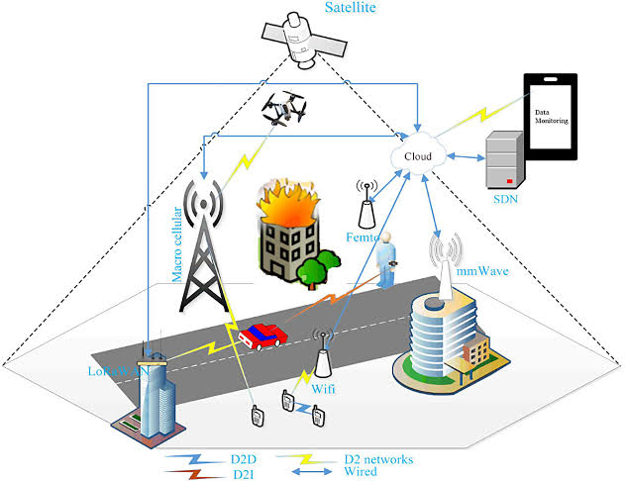
3.3.4 A Probabilistic Bi-Objective Model for Humanitarian Location-Routing Under Uncertain Demand and Road Closure [19]
Objective: Jointly decide cross-dock facility locations and vehicle routes for pre-disaster humanitarian logistics planning.
Methodology: Probabilistic bi-objective mixed model with explicit fuel-consumption estimation, solved using multi-objective particle swarm optimization (MOPSO).
Technology/Dataset: Probabilistic disaster-scenario simulation with heterogeneous vehicle fleets and uncertain road closures.
Key Findings: MOPSO effectively balances cost and service-level trade-offs under probabilistic disaster scenarios and road-network disruption.
Limitations: Oriented toward strategic, pre-disaster planning rather than adaptive, real-time post-disaster re-optimization.

4. Comparative Literature Survey Table
Table 1 compares the eighteen reviewed studies across research problem, methodology, dataset/tools, key findings, limitations, and the specific research gap each study leaves open, in relation to the assigned problem of building an integrated AI-powered disaster relief resource allocation and coordination platform.
Table 1: Comparative summary of reviewed literature
Author/Year | Research Problem | Methodology | Dataset/Tools | Key Findings | Limitations | Research Gap
Chamola et al. (2024) | AI across full disaster-management lifecycle | Systematic literature review of AI techniques (ML/DL, NLP, computer vision) across mitigation, preparedness, response, recovery | Secondary data: social media, satellite imagery, sensor feeds | Identifies AI use-cases in every disaster phase; highlights lack of unified data pipelines | Descriptive review only; no working system or quantitative evaluation | No integrated platform linking prediction, allocation and coordination
Journal of AI Research (2022) | Predicting and mitigating disaster impact | Deep-learning forecasting fused with reinforcement-learning based dynamic resource allocation | Historical disaster records, meteorological data, sensor networks | Improved forecasting accuracy; RL-based allocation reduces response time and casualties | High computational cost; data-integration complexity; no field deployment | Lacks real-time multi-agency coordination layer
Bhuiyan et al., PMC (2023) | AI in disaster risk & emergency health management | Critical appraisal / narrative synthesis of AI, GIS, remote sensing applications | Public-domain secondary sources | AI improves situational assessment and recovery planning | Conceptual; no empirical validation or benchmarking | No framework for translating assessment into resource dispatch
Moroccan Earthquake Study, arXiv (2023) | Post-earthquake road/damage assessment for relief routing | CNN and transformer models on drone/satellite imagery; facility-location optimization | Satellite & drone imagery, building/road damage datasets | Accurate accessible-road mapping guides relief and facility siting | Optimization treated separately from imagery pipeline; limited real-time integration | No closed loop between damage detection and live logistics optimization
Springer Comprehensive Review (2025) | AI for prediction and resource optimization | Mixed-methods: systematic review plus quantitative analysis of 6 case studies | Six real-world disaster case studies | ML improves prediction accuracy by up to 25%; AI optimizes resource allocation by up to 30% | Small case sample; ethical/privacy issues under-addressed | Fairness and equitable distribution mechanisms remain unresolved
Wang, Zhang, Lu & Gui, PLOS ONE (2025) | Multi-objective emergency resource scheduling in chemical parks | Three-objective mixed-integer model (time, coverage, fairness) solved via improved NSGA-II | Simulated chemical-park hazard scenarios | NSGA-II outperforms weighted-sum and MOGWO in convergence, diversity and stability | Domain-specific (chemical parks); static single-hazard scenario | Fairness quantification not generalized to multi-hazard, multi-agency disasters
Human-AI Systematic Review, arXiv (2025) | Human-AI collaboration in disaster decision-making | Survey of KNN classifiers, multi-agent MDPs, attention-based hybrid planners, IDSS | Mixed: shelter socio-demographic data, simulated multi-agent environments | KNN shelter-allocation model reaches 85% classification accuracy; MDPs simulate agent coordination | Most models tested only in simulation; delayed/incomplete data handling still immature | Weak bridge between human judgment and autonomous multi-agency scheduling
AI & Big Data Ethics, ScienceDirect (2025) | Ethical/practical issues of AI in disaster response | Critical/conceptual analysis of deployed AI-big-data systems | Literature and case examples | Highlights algorithmic bias and inequitable aid distribution risks | No technical solution proposed | Absence of fairness-aware allocation algorithms in practice
Emergency Logistics Blockchain Study, PMC (2024) | Traceable, optimized emergency-logistics allocation | Consortium blockchain + Hybrid Genetic Simulated Annealing (HGASA) algorithm | Simulated emergency-logistics network | Reduces transport time and cost; improves fairness and data traceability | Blockchain consensus overhead; not tested at national multi-agency scale | No integration with real-time IoT sensing or demand-prediction models
IoT Public-Safety Alert System, Sci. Reports (2025) | Real-time multi-sensor emergency alerting | IoT sensor fusion with severity-scoring engine and GIS-based dashboards | Multi-sensor smart-city testbed (fire, gas, biometric, motion) | Alert latency <450 ms; >95% detection accuracy; scales to 12,000+ devices | Lab/simulated smart-city environment; not validated in large-scale natural disasters | No downstream resource-allocation or inter-agency logistics module
AI/ML-Powered GIS Review, Taylor & Francis (2025) | AI-GIS integration for proactive disaster resilience | Systematic review of AI+GIS literature for early warning and coordination | Secondary literature synthesis | AI-GIS fusion improves real-time intelligence and multi-agency collaboration | Review-level evidence only; implementation barriers not quantified | Interoperability standards across agency GIS platforms remain undefined
GIS in Disaster Response / EMHelp, ResearchGate (2025) | BIM-GIS-IoT platform and AI decision-support (EMHelp, Algeria) | ML/DL scenario simulation with human-validated decision support (EMHelp/ORSEC framework) | Multi-risk databases, IoT sensors, structural/BIM models | Optimizes evacuation routes; improves inter-agency response time | Delayed decision-making and poor inter-agency data sharing persist as barriers | No standardized architecture generalizable beyond single-country regulatory context
AI-Driven DSS for Humanitarian Logistics, Transp. Res. (2026) | Systematic review of AI in humanitarian logistics DSS (2008-2024) | Review of ML, DL, NLP, RL and AI-IoT methods across forecasting, facility location, routing | Aggregated peer-reviewed literature, 2008-2024 | Strong coverage of early-response logistics; recovery/resilience under-researched | Fragmented datasets, low model explainability, siloed system design | Lack of unified, explainable, end-to-end platform spanning prediction to coordination
GIS-IoT MCDM Disaster Risk Study, ResearchGate (2023) | Multi-criteria disaster risk management | Multi-Criteria Decision Making (MCDM), IoT sensing, CDNN, IMOO integration | IoT sensor case-study data | Combined IoT-GIS-MCDM improves real-time understanding of disaster scenarios | Infrastructure and power-reliability constraints in the field | Predictive and coordination layers not yet fused with MCDM outputs
IoT-GIS Remote-Area Relief Study, JCS-TECH (2025) | Optimizing relief distribution in remote/low-infrastructure areas | IoT sensor tracking + GIS spatial route optimization with live dashboard | Field logistics-asset tracking data | Improves situational awareness, route planning and reporting in remote regions | Small-scale prototype; connectivity dependent in remote/no-network zones | No AI-based demand-forecasting or multi-agency inventory-sharing layer
Robust 2-Echelon UAV Routing, arXiv (2022) | Last-mile relief delivery under demand uncertainty | Two-echelon robust optimization (trucks + UAVs) with column-and-constraint generation | Simulated post-disaster transportation networks | Robust routing maintains feasible delivery despite damaged road networks and uncertain demand | High computational complexity; UAV payload/range constraints simplified | No live integration with real-time demand-sensing or shelter-occupancy data

4.1 Comparison on Key Problem-Specific Parameters
Across the reviewed literature, four parameters recur as the basis for comparing approaches:
- Prediction accuracy: deep-learning and ensemble ML models report 25-30% improvement over traditional statistical baselines for disaster and demand prediction [5], and classification accuracy of 85% for shelter-allocation matching [7].
- Optimization performance: metaheuristic and evolutionary algorithms (improved NSGA-II [6], HGASA [9], MOPSO [19]) consistently outperform simple weighted-sum or single-objective baselines on convergence, cost, time, and fairness metrics, but are validated mostly in simulation.
- Real-time responsiveness and scalability: IoT-based alerting systems demonstrate sub-second latency and scalability to thousands of concurrent devices [10], but this performance has not been demonstrated jointly with logistics optimization or multi-agency data sharing at the same scale.
- Coordination and fairness: blockchain-based traceability [9] and fairness-aware scheduling [6] show technical promise, yet ethical/fairness critiques [8] and long-standing inter-agency information-sharing barriers [15] indicate that governance and equity are still largely unsolved at the systems level.

5. Limitations and Challenges of Existing Approaches
Synthesizing the reviewed literature, the following limitations and challenges recur across existing research on AI-based disaster relief resource allocation:
Fragmented, siloed systems — Prediction models, routing/allocation optimizers, IoT monitoring systems, and inter-agency communication tools are almost always studied and built as separate systems, rarely as one integrated pipeline [1], [4], [9], [16].
Simulation-only validation — A large share of optimization and reinforcement-learning approaches (NSGA-II, MOPSO, robust 2E-VRP, multi-agent MDPs) are validated only on simulated or historical data rather than live field deployments [6], [7], [18], [19].
Data quality and integration complexity — Combining heterogeneous data sources — satellite imagery, IoT sensors, social media, agency records — introduces integration complexity, incomplete/delayed data, and high computational cost [2], [7], [16].
Limited explainability — Deep-learning and reinforcement-learning-based decision-support tools generally lack interpretability, which reduces trust and accountability for life-critical allocation decisions [16].
Fairness and equity risks — Automated allocation can reinforce systemic inequities unless fairness is explicitly modeled and audited; only a minority of studies quantify fairness as an objective [6], [8].
Persistent inter-agency coordination barriers — Communication, trust, and data-sharing obstacles between government agencies, NGOs, and responders identified over a decade ago [15] are still reported as unresolved in recent studies [11], [12].
Infrastructure dependency — IoT/GIS-based monitoring and remote-area distribution systems remain dependent on network connectivity and power availability, which are often the first casualties of a disaster [13], [14].
Governance and regulatory context-dependence — Decision-support platforms such as EMHelp are tightly coupled to a specific country's regulatory/emergency-planning framework, limiting direct generalizability [12].
6. Research Gap Analysis
The literature demonstrates strong, independently mature research in (a) AI-based disaster prediction and severity assessment, (b) optimization algorithms for resource scheduling and vehicle/UAV routing, (c) IoT-based real-time sensing and GIS-based spatial visualization, and (d) conceptual/critical treatment of coordination and ethical challenges. However, the survey reveals a clear and consistent research gap:
No reviewed study presents a single, real-time, end-to-end platform that simultaneously performs AI-based demand prediction, optimization-based logistics routing, IoT/GIS-based inventory and shelter monitoring, and transparent, fairness-aware multi-agency coordination.
Specifically, the following sub-gaps are identified:
- Integration gap: prediction, optimization, and coordination modules are developed and evaluated in isolation, with limited work on architecture that closes the loop between real-time sensing, forecasting, and dispatch decisions [1], [4], [9], [16].
- Explainability and trust gap: black-box ML/RL allocation models are rarely paired with explainable-AI techniques, limiting adoption by human decision-makers and accountability during audits [16].
- Fairness-by-design gap: fairness is treated as an afterthought or a single case-specific index (e.g., [6]) rather than a first-class, generalizable design principle embedded in the platform architecture [6], [8].
- Interoperability gap: absence of common data/API standards across government GIS systems, NGO databases, and IoT platforms prevents seamless multi-agency data sharing, a barrier documented as far back as 2013 and still unresolved [11], [12], [15].
- Resilience-under-degraded-infrastructure gap: most systems assume continuous connectivity and power, whereas real disasters frequently damage the very communication infrastructure the platform depends on [13], [14].
- Field-validation gap: the majority of optimization and AI models are validated only through simulation or small case studies rather than large-scale, multi-agency, real-world pilots [6], [7], [18], [19].
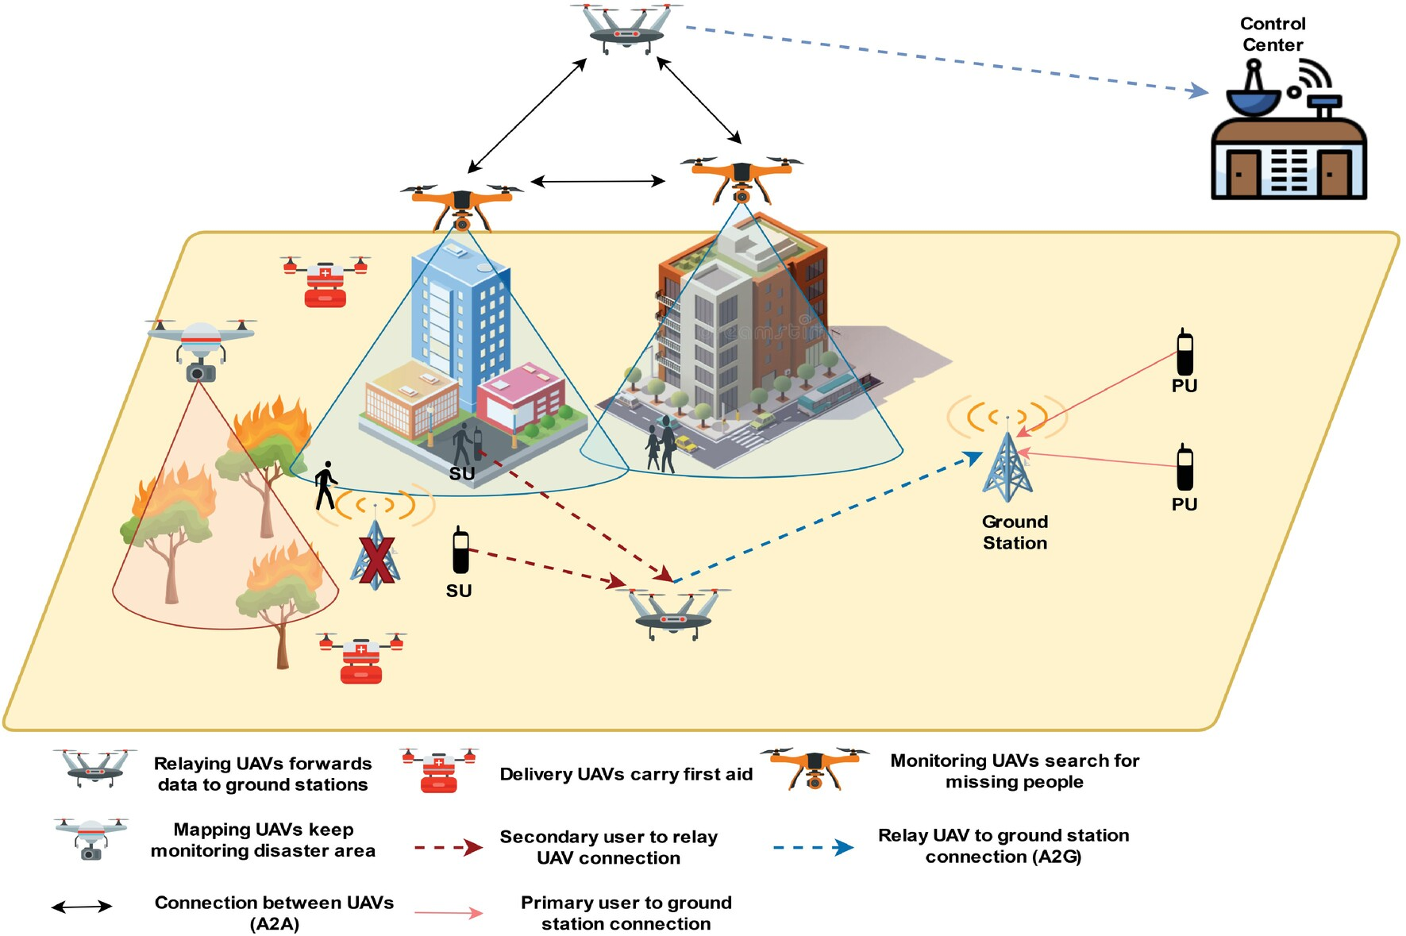

7. Future Research Directions
Based on the identified research gap, the following directions are proposed for the design and development of the AI-powered smart disaster relief resource allocation and coordination platform:
Unified, modular architecture — Design a single platform with loosely coupled but API-integrated modules for demand prediction, logistics optimization, IoT/GIS monitoring, and multi-agency coordination, rather than treating each as a standalone research artifact.
Explainable, hybrid human-AI decision support — Combine reinforcement-learning/optimization engines with explainable-AI layers and human-in-the-loop validation (as in EMHelp [12] and IDSS approaches [7]) so responders can trust and audit automated allocation decisions.
Fairness-aware optimization by design — Embed a generalizable fairness index (extending the fairness-quantification approach in [6]) as a first-class optimization objective alongside time, cost, and coverage.
Interoperable, standards-based data layer — Adopt open data standards and blockchain- or cloud-based shared ledgers (building on [9], [15]) to enable secure, real-time information exchange between government agencies, NGOs, and responders.
Resilient, low-connectivity operation — Incorporate edge-computing and delay-tolerant IoT communication so the platform can continue operating (in degraded mode) when centralized connectivity or power is lost, extending remote-area approaches such as [13], [14].
Real-time closed-loop learning — Use live IoT/GIS/social-media data to continuously refine demand-prediction and severity-assessment models during an ongoing disaster, rather than relying solely on pre-trained, static models [2], [10].
Large-scale, multi-agency field pilots — Move beyond simulation by conducting structured pilot deployments with actual disaster-management authorities to validate scalability, latency, and coordination benefits under real operational conditions [10], [17].
Dynamic, uncertainty-aware routing — Extend robust and stochastic routing models (2E-VRP with UAVs [18], probabilistic location-routing [19]) to re-optimize continuously as new road-damage and demand information arrives, rather than only at the planning stage.

8. Conclusion
This literature survey reviewed eighteen research works spanning AI-based prediction, optimization-based logistics, IoT/GIS-based monitoring, and multi-agency coordination in the context of disaster relief. While individual components of the proposed AI-powered disaster relief platform are well studied and show measurable performance gains — improved prediction accuracy, faster and fairer resource scheduling, low-latency IoT alerting, and richer GIS-based situational awareness — the survey confirms a clear research gap: the absence of an integrated, explainable, fairness-aware, and infrastructure-resilient platform that unifies these components into a single real-time coordination system for government agencies, NGOs, and emergency responders. Addressing this gap through a unified architecture, fairness-by-design optimization, interoperable data standards, and real-world multi-agency pilots forms the basis for the future development of the proposed platform, with the ultimate goal of faster relief delivery, more efficient resource use, and reduced human suffering during disasters.

References
[1] H. Wang et al., “Applications of Artificial Intelligence in Disaster Management,” in Proc. ICIRA / ACM Conf., 2024. [Online]. Available: https://dl.acm.org/doi/fullHtml/10.1145/3669754.3669802
[2] “Enhancing Disaster Response Systems: Predicting and Mitigating the Impact of Natural Disasters Using AI,” Journal of Artificial Intelligence Research, vol. 2, no. 1, 2022. [Online]. Available: https://www.researchgate.net/publication/390466139
[3] L. F. B. et al., “Potential Use of Artificial Intelligence (AI) in Disaster Risk and Emergency Health Management: A Critical Appraisal on Environmental Health,” PMC, 2023. [Online]. Available: https://pmc.ncbi.nlm.nih.gov/articles/PMC10712270/
[4] “Leveraging AI for Natural Disaster Management: Takeaways From The Moroccan Earthquake,” arXiv:2311.08999, 2023.
[5] “Leveraging AI for Disaster Management: A Comprehensive Review of Applications and Challenges,” in Proc. Springer Conf., 2025, doi: 10.1007/978-3-031-82377-0_16.
[6] Y. Wang, M. Zhang, J. Lu, and Y. Gui, “Research on multi-objective emergency resource scheduling optimization in chemical industrial parks,” PLOS ONE, 2025, doi: 10.1371/journal.pone.0332858.
[7] “Human-AI Use Patterns for Decision-Making in Disaster Scenarios: A Systematic Review,” arXiv:2509.12034, 2025.
[8] “AI and big data in disaster response: Ethical and practical challenges,” ScienceDirect, 2025. [Online]. Available: https://www.sciencedirect.com/science/article/pii/S295057632500025X
[9] “Research on emergency logistics information traceability model and resource optimization allocation strategies based on consortium blockchain,” PMC, 2024. [Online]. Available: https://www.ncbi.nlm.nih.gov/pmc/articles/PMC11104645/
[10] “Developing real-time IoT-based public safety alert and emergency response systems,” Scientific Reports, 2025, doi: 10.1038/s41598-025-13465-7.
[11] “Artificial intelligence and machine learning-powered GIS for proactive disaster resilience in a changing climate,” Geo-spatial Information Science / Taylor & Francis, 2025, doi: 10.1080/19475683.2025.2473596.
[12] “The Role of GIS in Disaster Response: Improving Efficiency and Overcoming Challenges,” ResearchGate, 2025. [Online]. Available: https://www.researchgate.net/publication/389524130
[13] “Application of GIS and IoT Technology based MCDM for Disaster Risk Management: Methods and Case Study,” ResearchGate, 2023. [Online]. Available: https://www.researchgate.net/publication/375256880
[14] “Integration of IoT and GIS for Optimizing Disaster Relief Distribution Response in Remote Areas,” Journal of Computer Science and Technology (JCS-TECH), 2025.
[15] N. Bharosa, J. Lee, and M. Janssen, “Challenges and obstacles in sharing and coordinating information during multi-agency disaster response: Propositions from field exercises,” Information Systems Frontiers, vol. 12, no. 1, pp. 49-65, 2010; as cited in “Event-Cloud Platform to Support Decision-Making in Emergency Management,” arXiv:1510.00225.
[16] “AI-driven decision support for disaster management and humanitarian logistics: Models, applications, and research challenges,” Transportation Research Part E, vol. 210, 2026.
[17] “Recent Advances in Disaster Emergency Response Planning: Integrating Optimization, Machine Learning, and Simulation,” arXiv:2505.03979, 2025.
[18] A Robust Optimization Framework for Two-Echelon Vehicle and UAV Routing for Post-Disaster Humanitarian Logistics Operations,” arXiv:2207.11879, 2022.
[19] Temiz et al., “A probabilistic bi-objective model for a humanitarian location-routing problem under uncertain demand and road closure,” International Transactions in Operational Research, 2025, doi: 10.1111/itor.13475.

